Naveen Kumar. T- Data Structures and Algorithms
Exercise 1: Inventory Management System

import java.util.HashMap;

class Product {
int productId;
String productName;
int quantity;
double price;

Product(int productId, String productName,
int quantity, double price) {

this.productId = productId;
this.productName = productName;
this.quantity = quantity;
this.price = price;
}

public String toString() {
return "ID: " + productId +
", Name: " + productName +
", Quantity: " + quantity +
", Price: " + price;
}
}

public class InventoryManagementSystem {

static HashMap<Integer, Product> inventory =
new HashMap<>();

public static void addProduct(Product p) {
inventory.put(p.productId, p);
System.out.println("Product Added");
}

public static void updateProduct(
int id,
String name,
int quantity,
double price) {

if (inventory.containsKey(id)) {

Product p = inventory.get(id);

p.productName = name;
p.quantity = quantity;
p.price = price;

System.out.println("Product Updated");
} else {
System.out.println("Product Not Found");
}
}

public static void deleteProduct(int id) {

if (inventory.containsKey(id)) {

inventory.remove(id);
System.out.println("Product Deleted");

} else {

System.out.println("Product Not Found");
}
}

public static void displayProducts() {

System.out.println("\nInventory:");

for (Product p : inventory.values()) {
System.out.println(p);
}
}

public static void main(String[] args) {

addProduct(new Product(101,
"Laptop", 20, 50000));

addProduct(new Product(102,
"Mouse", 100, 500));

addProduct(new Product(103,
"Keyboard", 50, 1200));

displayProducts();

updateProduct(102,
"Wireless Mouse", 80, 700);

displayProducts();

deleteProduct(103);

displayProducts();
}
}

Output:
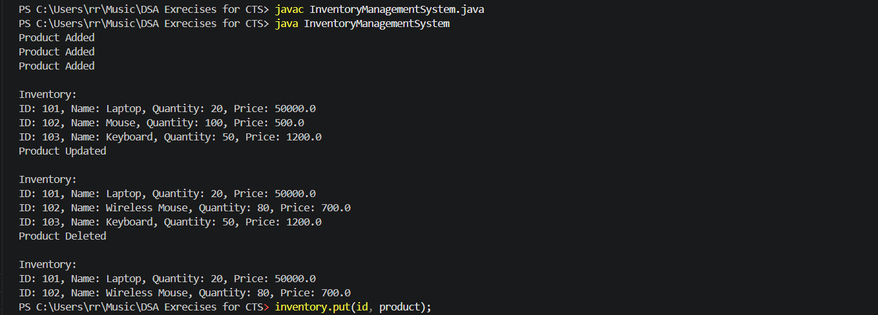

Exercise 2: E-commerce Platform Search Function
Output:
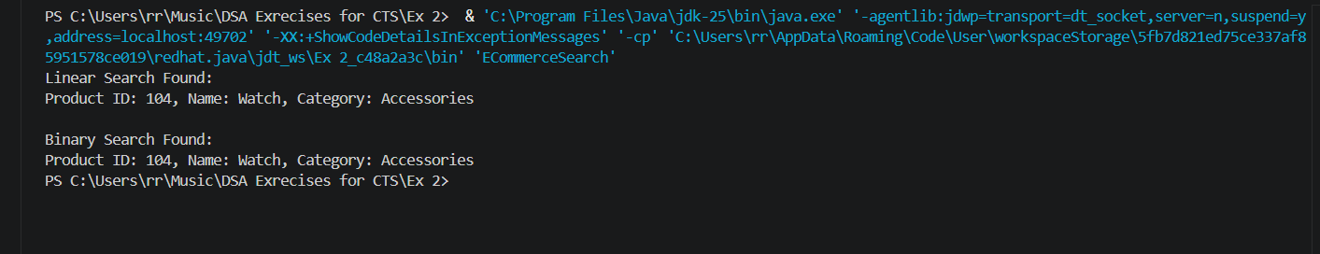

Exercise 3: Sorting Customer Orders
Output:
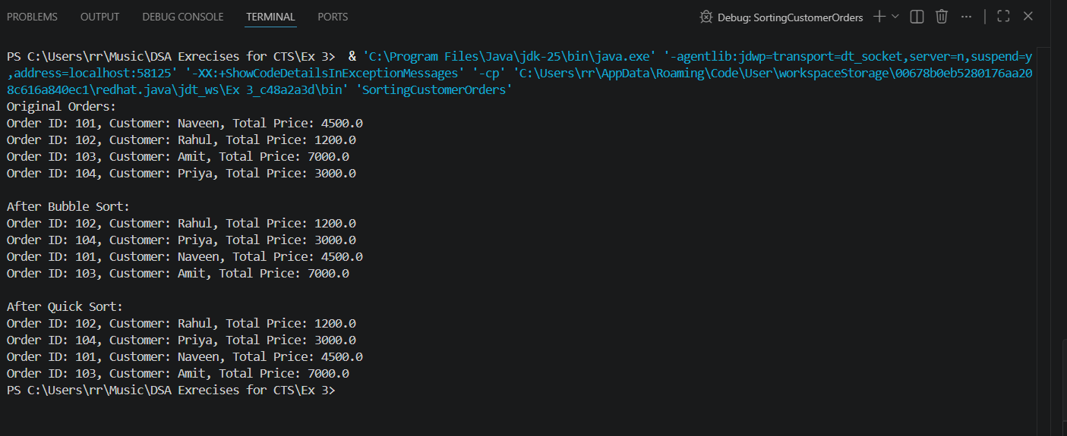
Exercise 4: Employee Management System
Output:
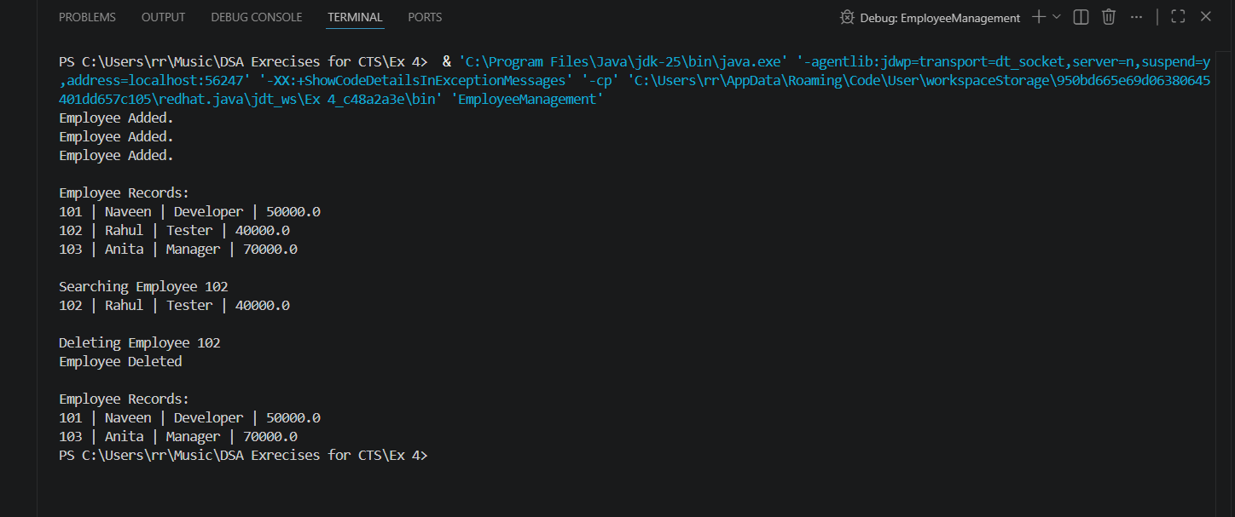

Exercise 5: Task Management System
Output:
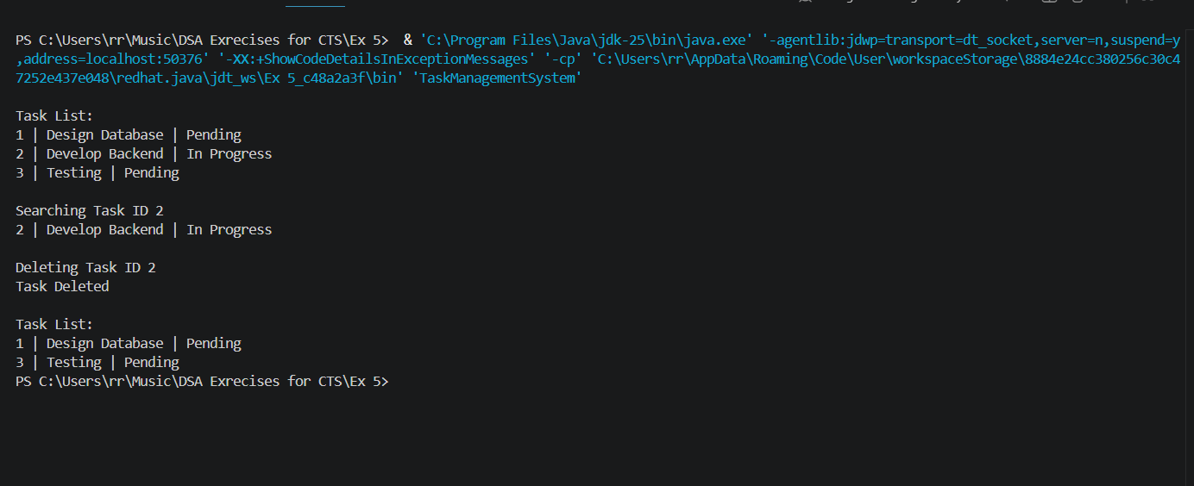
Exercise 6: Library Management System
Output:
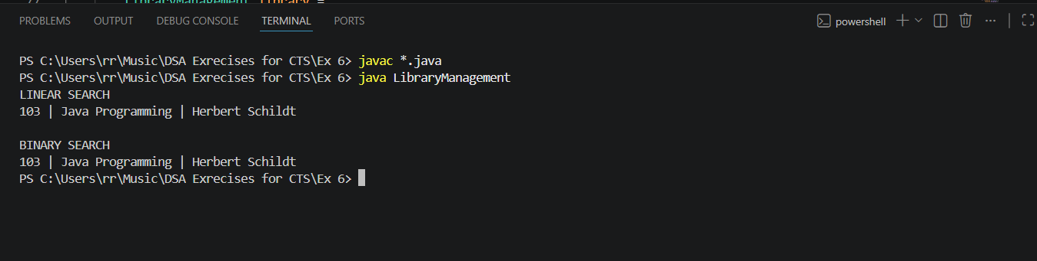

Exercise 7: Financial Forecasting
Output:
